Name:A.Daya sagar

Reg NO:192011412

Course code :CSA1140

Course name: OOAD

**Exp No:12**

**Exp Name: Online voting system**

Use case Diagram

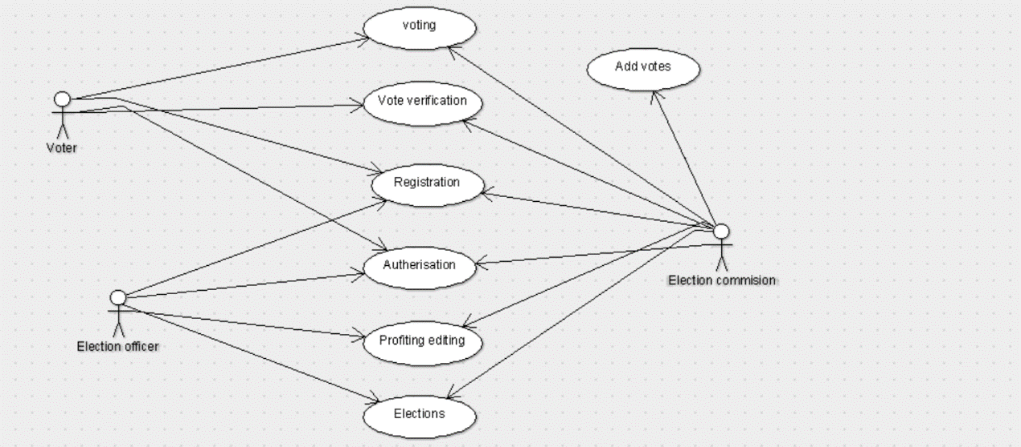

Class Diagram:

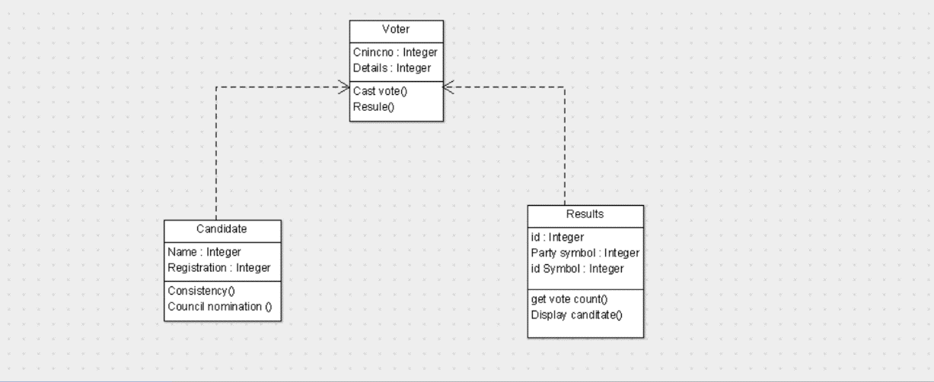

State Chart Diagram:

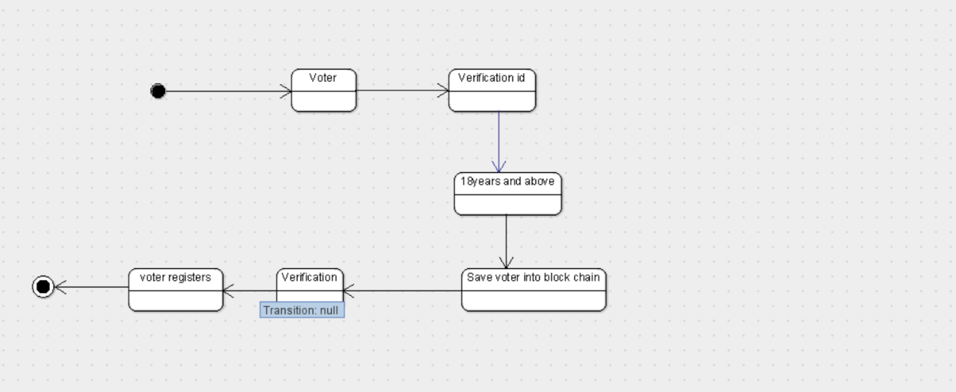

Activity Diagram:

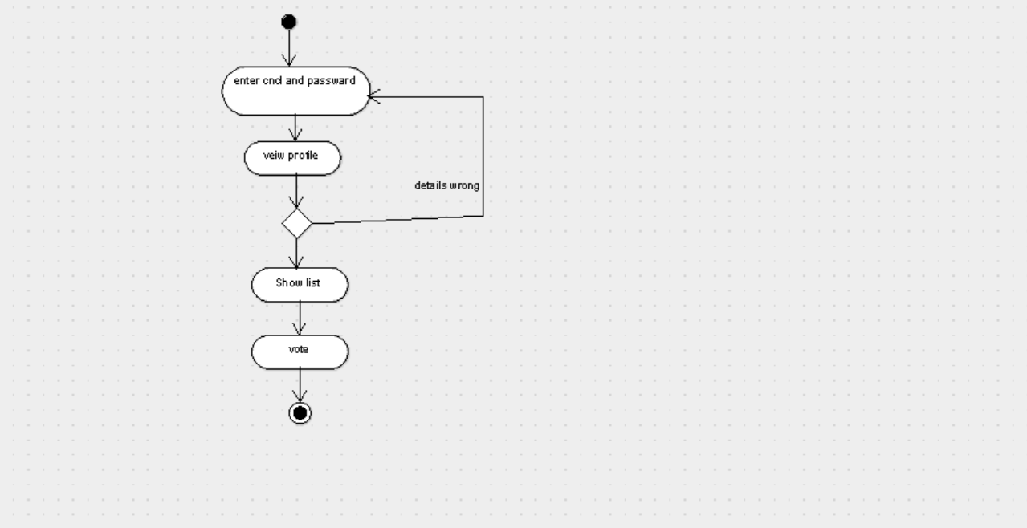

Sequence Diagram:

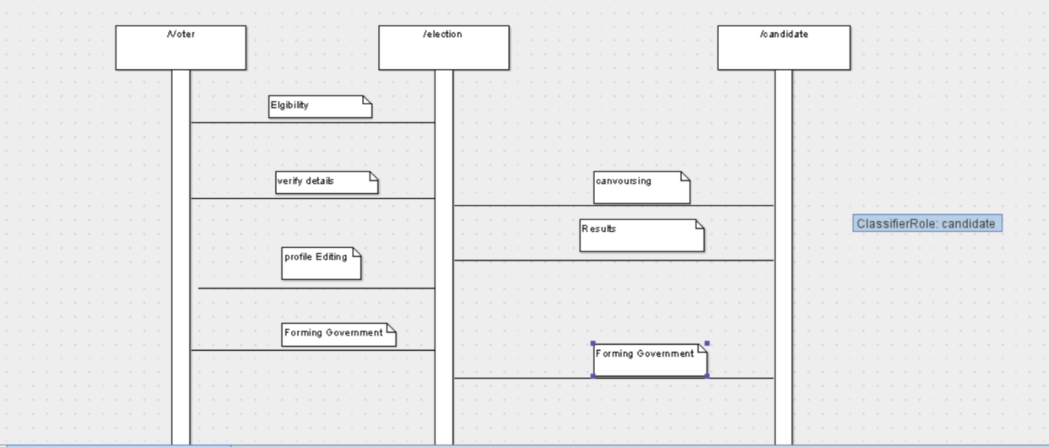

Deployment Diagram:

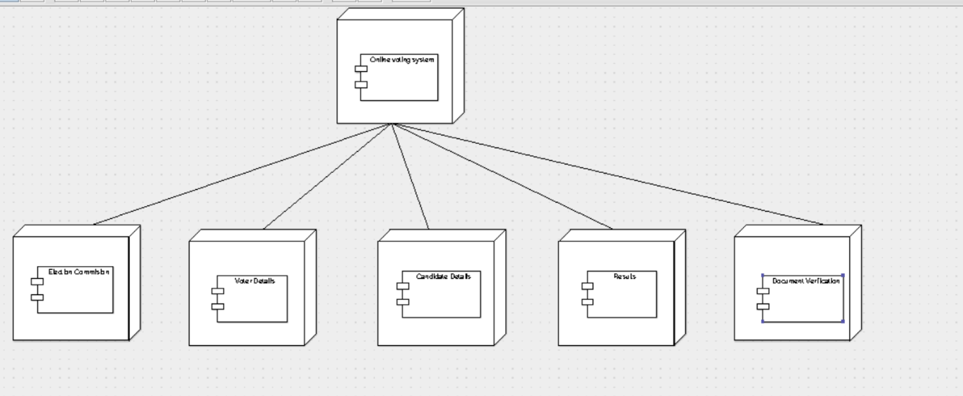

Collabration Diagram:

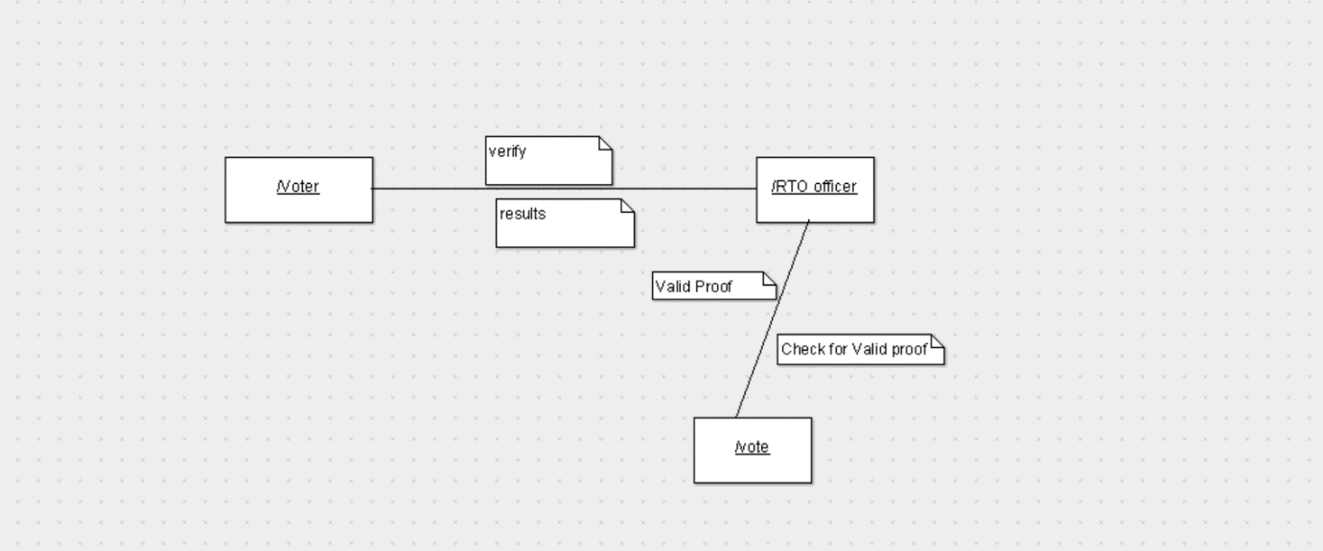

Component Diagram:

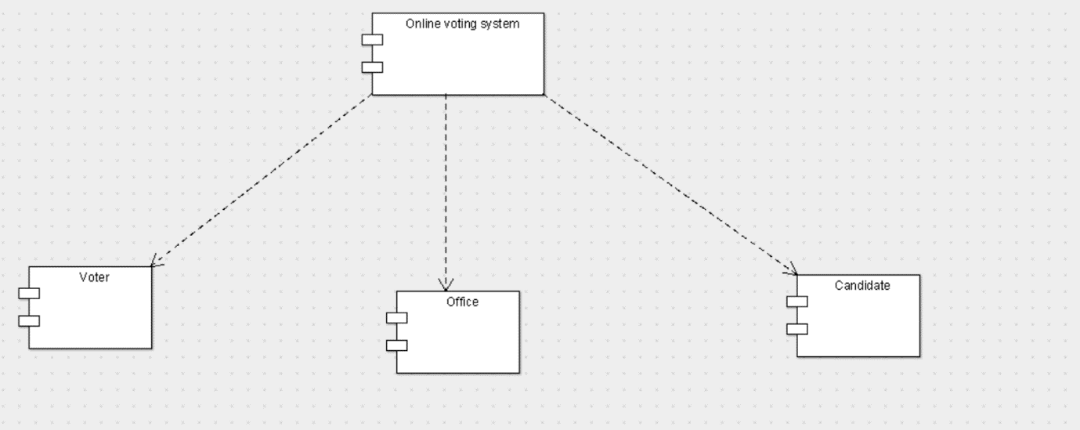

Package Diagram:

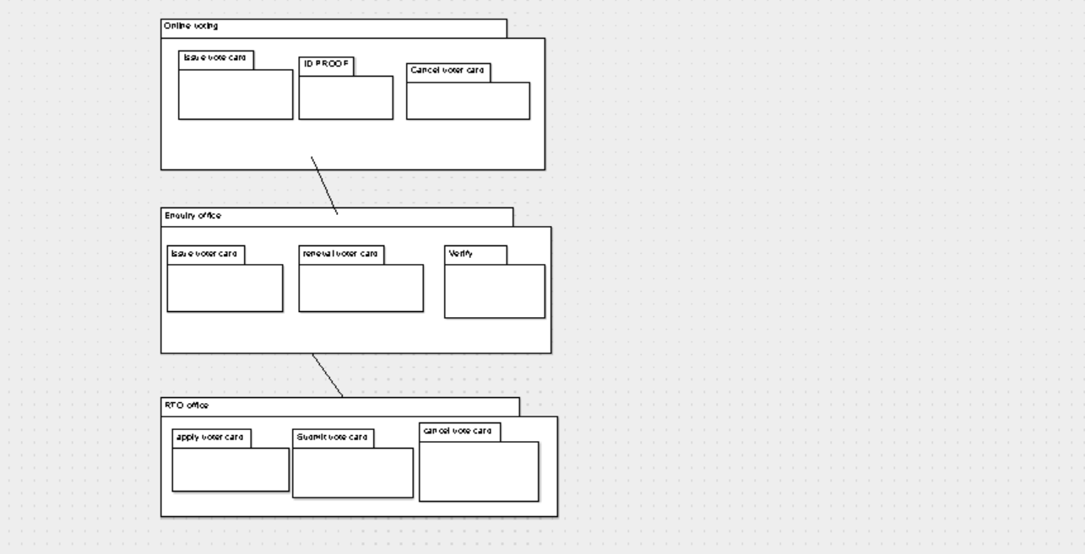

Code:

Voter Registration :

public class Voter card extends Election Management

{

public String Voter detailos;

public Integer number ;

private void verify() {

}

public void allocate number() {

}

}

Election:

public class voter id {

public String Name;

public String Proof of Owenership;

public String voter id Details

public void Owener Details() {

}

public void id number() {

}

}

Vote Registration Management:

public class avoter Management {

public String vote details;

public String election Details;

public String results Information;

private void Sale Certificate() {

}

public void Road Fitness() {

}

public void results Details() {

}

}